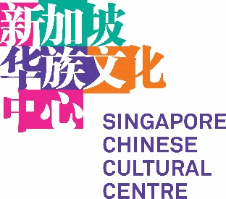

OPEN CALL APPLICATION FORM
公开招选申请表格

Applicant’s Name:
申请者姓名：
Name of Arts Group or Organisation (if applicable):
艺术组织/团体名称（若有）：
Email Address:  电邮： | Contact Number:  联络号码：
Nature of organisation:  团体性质：  (e.g. company/ society/ IPC charity etc)  （例：公司/社团/慈善团体等） | Nationality (for individuals):  国籍（个人适用）：
Project Title:  计划名称： | Nature of Project  计划性质  (e.g Film Screening, Exhibition, Performance, Talk, Workshop, etc)  （例：电影放映会、展览、表演、讲座、工作坊等）
Proposed Dates of Project  (public presentation)  建议计划日期（公演）  Start: (dd/mm/yyyy)  End: (dd/mm/yyyy)  开始：（日日/月月/年年年年）  结束：（日日/月月/年年年年）  Time-sensitive? If yes, why?  是否有时效性？如有请提供原因。 | Proposed Duration of Project  (from conceptualisation, rehearsals  to closing of financial accounts)  建议计划期  （从构思、彩排到财务结账）  Start: (dd/mm/yyyy)  End: (dd/mm/yyyy)  开始：（日日/月月/年年年年）  结束：（日日/月月/年年年年）
Target Audience:  主要受众：  Type of audience (profile):  受众属性：  Size of audience:  受众人数： | Estimated Project Budget:  预计所需经费：
Description of the project (within 300 words)
计划描述（限300字）

What outcomes do you hope to achieve?
您预期的目标是什么？
(both qualitative and quantitative, within 300 words)
（请提供质性与量性目标，限300字）
(e.g generate greater appreciation, change public mindset, etc)
（例：提升鉴赏能力、改变公众思维等）

How do your outcomes complement SCCC’s vision and mission?
您的目标结果如何与本中心的愿景和使命相辅相成？
(within 300 words)
（限300字）
(Please refer to SCCC’s mission https://www.singaporeccc.org.sg/about/)
（本中心使命请参阅https://www.singaporeccc.org.sg/about/）

Breakdown of Project Budget: (please be as detailed as possible)
计划经费分配：（请尽量详列）

Please also indicate:
请同时注明：
- if there is any expected ticketing revenue
是否计划售票
- how much you would like SCCC to contribute towards this budget
您希望本中心提供的经费资助数目
- Any sponsorship (income) from external sources
是否有外来赞助收入

Other Information (if available):
其他资讯（若有）：

Individual or organisation resume:
个人或团体履历：
Organisation structure:
团体结构：
Years of operation:
经营年数：
Examples of past comparable works
过往作品举例

