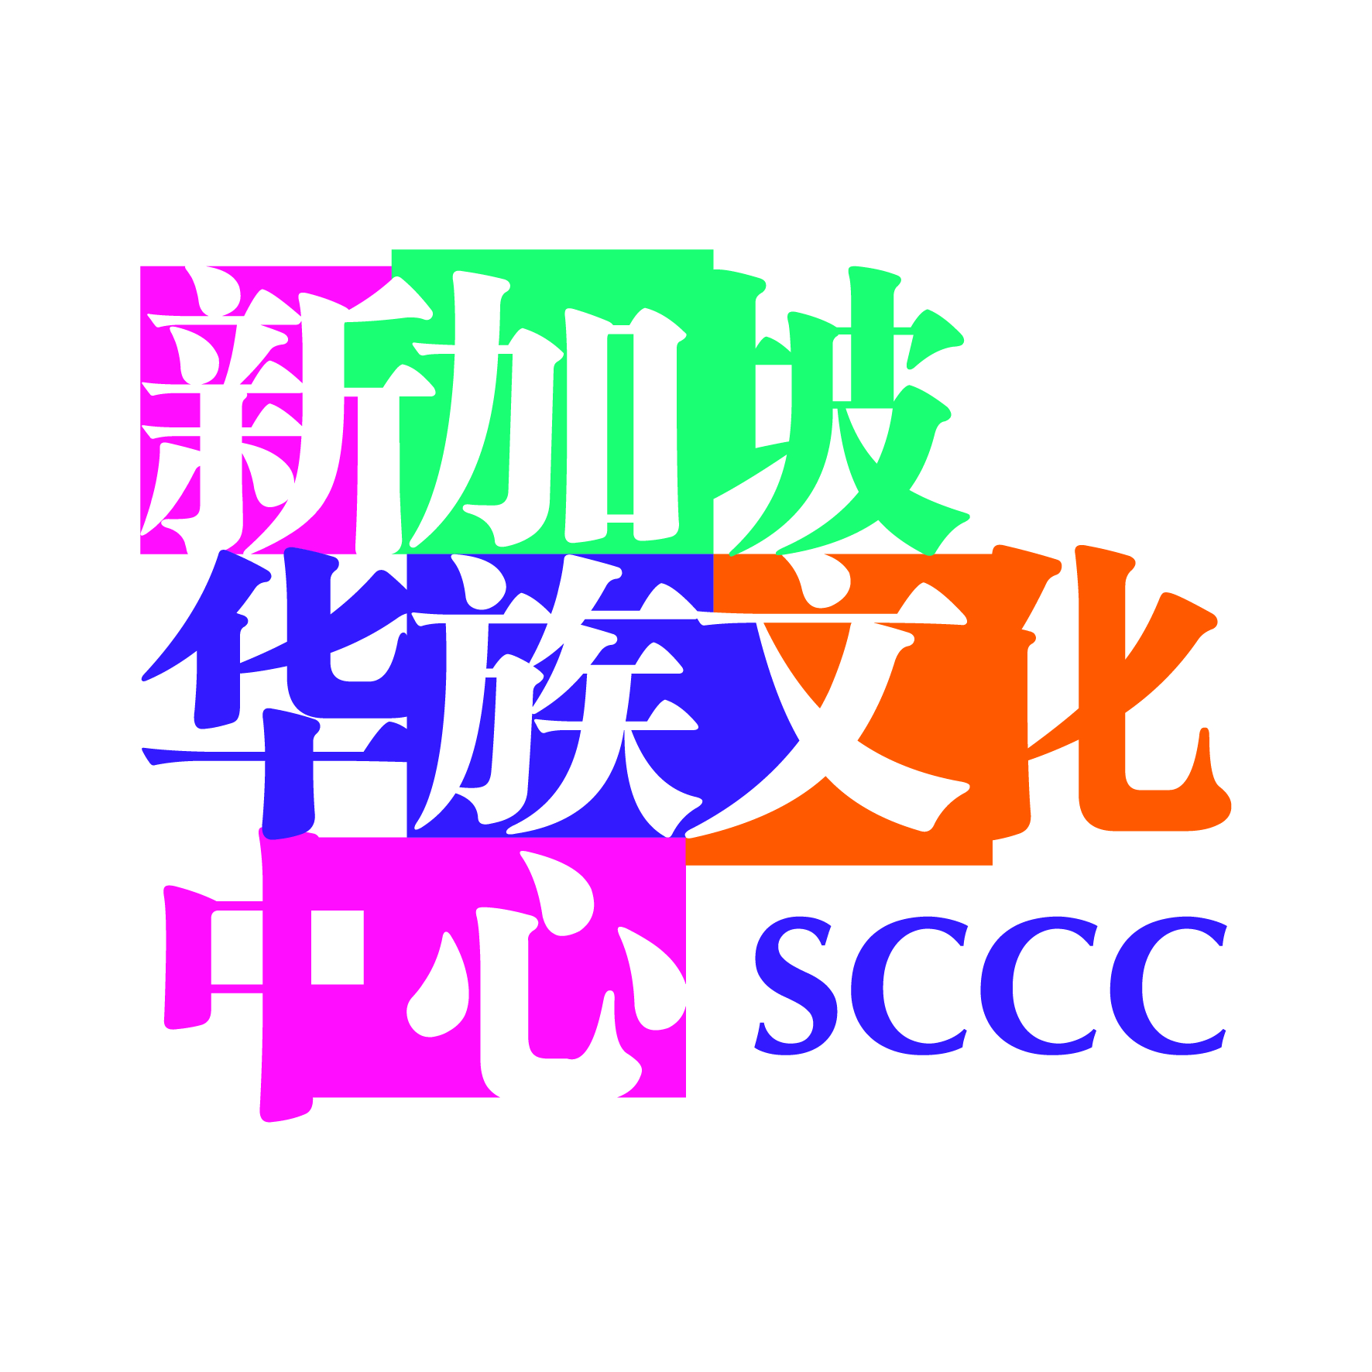

SCCC PUBLICATION GRANT

APPLICATION FORM

Your application for funding will need to include the following:

PART I: APPLICANT AND PROJECT DETAILS

PART II: DETAILED PROJECT PROPOSAL

Please complete all the fields carefully and indicate NIL if not applicable.

PART I APPLICANT AND PROJECT DETAILS
(A) TYPE OF APPLICATION
Type |  |  | Individual/Group (please fill in sections BI, C and D)  Organisation (please fill in sections BII, C and D)  Educational Institutions (please fill in sections BII, C and D)
(BI) APPLICANT INFORMATION For Individual/Group Applicants
Name of Individual / Appointed Representative (as in NRIC)  Salutation (choose one) Mr/Ms/Mdm/Dr  Full Name (underline surname) |  |  |  |  |  | NRIC (last three number and alphabet)
 |  |  |  |  |  | Nationality
Occupation |  |  |  |  |  | Date of Birth |  |  |  | Age
Address  Postal Code |  |  |  |  |  | Marital Status |  |  |  | Sex
Mailing address (if different from the address above) |  |  |  |  |  | Contact  (HP) (O)  Email
Do you have any co-applicants? |  | Name of co-applicant: |  |  |  |  |  | NRIC (last three number and alphabet)
Yes  No | No |  |  |  |  |  |  | Nationality
(BII) APPLICANT INFORMATION For Organisations/Educational Institutions
Registered Name of Company with Accounting & Corporate Regulatory Authority / Registry of societies

Correspondence Address
Contact Person |  |  |  |  | Designation
Telephone Number |  |  | Fax Number |  | Email Address
ACRA / ROS UEN |  |  |  |  | Date of Registration
Organisation registered as:
Non-profit organisations: Charity / Educational / society / associations / others (please specify): For-profit organisations applying in collaboration with non-profit partner:
- Sole proprietorship / Partnership / Private Limited / Others (please specify): _____________
- Non-profit partner (please specify):

Organisation Activity (Please Specify e.g. to promote understanding and appreciation of culture):
PART II DETAILED PROJECT PROPOSAL
(C) Project Details
Project Title
Objective(s) of Project
Primary Language Medium of Project |  |  |  |  |  |  | Will the project be presented in more than one language? If yes, please state the languages.  SCCC recommends for the project to be presented in English and Chinese.
Project Completion / Launch Date  DD/MM/YYYY)  / / |  |  |  | Launch Event  Yes Launch Date: |  |  |  |  | No
 |  |  |  | Guest of Honour  Yes: |  |  |  |  | No
Dates of Major Milestones
Brief Description of Project
Please describe the project, its originality in terms of concept, its contribution to promoting Chinese Singaporean identity, arts and culture, as well as the quantitative and qualitative impact the project will have on the local and international cultural sectors.
Have you applied for funding for this project from other sources? If yes, please specify details of the organisation/agency and the incentive(s), and include this in your budget:
 | Yes, pending reply from:  Yes, funding confirmed from:  Yes, but unsuccessful: |  | No
Please check the following items for this project:

Yes, the project is original and has not been published before.

Yes, research for this project has been completed.

PART III OTHER INFORMATION (Please provide information for the past three years)
a | Have any legal proceedings ever been taken against the individual or organisation, including those which have commenced, concluded or are ongoing?  Yes No  If yes, please specify details:
b | Are any of the company directors, shareholders, sole-proprietors un-discharged bankrupt?  If yes, please specify details:  Name/NRIC No:
c | Is there any conflict of interest between the applicant and vendors or services being used for project?  Yes No  If yes, please specify details:
PART IV IMPORTANT NOTICE BEFORE SUBMMISSION
By submitting this application, the applicant warrants that the facts stated in this application and the accompanying information are true and correct to the best of the applicant’s knowledge and that the applicant has not withheld/distorted any material facts.

The applicant understands that if the applicant obtains the grant by false or misleading statements, the applicant will be prosecuted accordingly. In addition, Singapore Chinese Cultural Centre (SCCC) may, at its discretion, withdraw the grant and recover immediately from the applicant any amount of the grant that may have been disbursed.
Name of Applicant |  | Designation
Telephone Number |  | Email Address

Note: SCCC reserves the right not to proceed with disbursement should there be circumstances which warrant a withdrawal of the grant.

Annex A

PART II: DETAILED PROJECT PROPOSAL

Your proposal is an important part of our assessment of your application. It should not exceed 2,000 words and should be submitted as a separate document. Your proposal should address each of the four sections below. We have come up with some guiding questions that you may wish to use as you craft your proposal. Not all guiding questions under each heading will be relevant to every application – feel free to add other points that you feel are important for us to know.

I | What Would You Like To Do?
- What are your publishing philosophy and objectives? How do these shape your selection of the proposed titles in this application?
- Have your existing books won any recent awards and received any critical response?
- How different are your proposed titles from your previous titles and other works you see today in your domain?
- What is the scale and significance of your proposed titles? You can also discuss the adaptation potential and plans for each title if relevant.
- How do you think your titles can have an impact on Chinese arts and culture in Singapore and/or internationally?
- What will the success of your titles look like to you?

II | Who Is Involved?
- Who are the authors and other main people involved? How have they contributed to the development of the cultural scene in Singapore?
- Will you be engaging editors for all your proposed titles?
- How will your editors work with your authors to refine their manuscripts? (e.g. structural editing, copyediting).
- Who are the other publishing, marketing and distribution partners and platforms you plan to collaborate with? What will they contribute to the execution of your project?

III | How Will You Carry Out the Activity?
- What stage of planning are you at now?
- How do you normally manage and execute the main stages of publishing, from selecting a title to production, marketing and distribution?
- What resources (financial or otherwise) have you identified to successfully produce and present your work to a wider audience? How do you plan to obtain these resources (e.g. do you have a sponsorship or revenue target)?

IV | How Will You Get the Word Out?
- How do you plan to promote and distribute each of your proposed titles? Do you have plans to sell your titles overseas?
- Who are the different audiences your titles aim to reach, and why are they important to you? Please be specific, e.g. students aged 13-18, people new to literary arts etc.
- How would you describe your existing audience base? Are you planning to engage new audiences with your project?
- How many readers do you hope to reach with each title?

Annex B

SCCC Publication Grant – Detailed Project Proposal Form
Please refer to the checklist of guiding points for each section can be found in Annex A.

- Overview (Describe your book in two or three paragraphs (500-1000 words or less).

About the Author and Partner/s (e.g. Illustrator)

- Timeline (List the major milestones of your project)

Target Audience/Market

- Marketing and Promotion/Publicity (Detail your comprehensive plan to actively promote the book)

- Detailed Table of Contents (Include the full Table of Contents, with detailed summaries of each chapter. It needs to give a comprehensive, detailed description of what the book will contain)

- Budget (Please include a realistic, detailed and complete project budget/spending, with projected revenue)

Costs Items | Costs / $
 | S$
 | S$
 | S$
 | S$
 | S$
PROJECTED REVENUE (If applicable)  (If to be confirmed, indicate TBC; if not applicable, indicate NA)  Please provide breakdown if available | S$
TOTAL COST OF PROJECT | S$
AMOUNT REQUESTED FROM SCCC  Please note the grant supports up to 50% of total project costs, capped at S$50,000 per Financial Year | S$

Applicants are required to submit one (1) softcopy of this application form and all supporting materials in

Microsoft Word format to:

publicationgrant@singaporeccc.org.sg

